15.)WAP to check whether the number entered is palindrome or not.

int main()

{ int n,r,sum=0,temp;

cout<<"Enter the Number=";

cin>>n;

temp=n;

while(n>0)

{ r=n%10;

sum=(sum*10)+r;

n=n/10;}

if(temp==sum)

cout<<"Number is Palindrome.";

else

cout<<"Number is not Palindrome.";

return 0; }

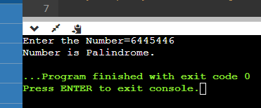

14.)WAP to print the Fibonacci series in a given range.

int main() {

int n1=0,n2=1,n3,i,number;

cout<<"Enter the number of elements: ";

cin>>number;

cout<<n1<<" "<<n2<<" ";

for(i=2;i<number;++i)

{ n3=n1+n2;

cout<<n3<<" ";

n1=n2;

n2=n3;}

return 0; }

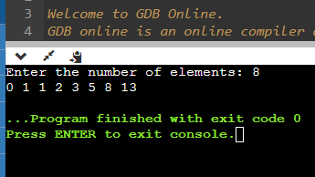

13.)WAP to check whether the number is Armstrong or not.

int main() {

int num, originalNum, remainder, result = 0;

cout << "Enter a three-digit integer: ";

cin >> num;

originalNum = num;

while (originalNum != 0) {

remainder = originalNum % 10;

result += remainder * remainder * remainder;

originalNum /= 10;}

if (result == num)

cout << num << " is an Armstrong number.";

else

cout << num << " is not an Armstrong number.";

return 0;}

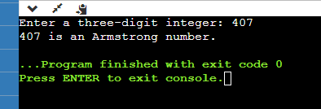

12.)WAP to print reverse of a number.

int main() {

int n, reversed_number = 0, remainder;

cout << "Enter an integer: ";

cin >> n;

while(n != 0) {

remainder = n % 10;

reversed_number = reversed_number * 10 + remainder;

n /= 10;}

cout << "Reversed Number = " << reversed_number;

return 0;}

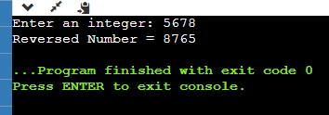

11.) WAP to print all digits of a number and their sum.

int main()

{int n,sum=0,m;

cout<<"Enter a number: ";

cin>>n;

while(n>0){

m=n%10;

sum=sum+m;

n=n/10;}

cout<<"Sum is= "<<sum<<endl;

return 0;}

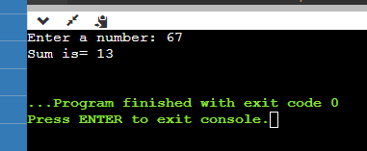

10.)WAP to check whether a number is prime or not.

int main() {

int i, n; bool is_prime = true;

cout << "Enter a positive integer: ";

cin >> n;

if (n == 0 || n == 1) {

is_prime = false;}

for (i = 2; i <= n/2;i++) {

if (n % i == 0) {

is_prime = false;

break;}}

if (is_prime)

cout << n << " is a prime number"; else

cout << n << " is not a prime number";return 0;}

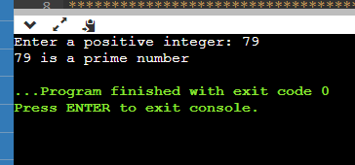

9.)WAP to calculate factorial of a number.

# include<iostream>

using namespace std;

int main()

{

int i,fact=1;

int number=5;

for(i=1;i<=number;i++)

{

fact=fact*i;

}

cout<<fact;

return 0;}

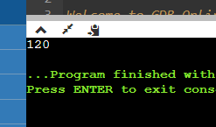

8.)WAP for printing multiplication table of a number. For eg. Display should be “ 2 X 1 = 2”

# include<iostream>

using namespace std;

int main()

{

int number;

cout<<"Enter the number";

cin>>number;

for(int i =1;i<=10;i++)

{ cout<<number<<"*"<<1 <<"=" <<number*i<<endl; }

return 0;

}

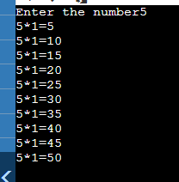

7.)WAP for finding sum of all odd numbers till 20.

# include<iostream>

using namespace std;

int main()

{ int number,sum=0;

cout<<"Enter the number";

cin>>number;

for(int i = number;i<=20;i++)

{ if(i%2 ==1){

sum+=i;}}

cout<<sum;

return 0;}

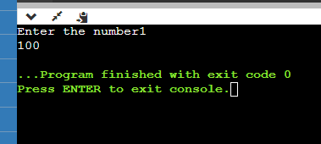

6.)WAP for finding sum of all even numbers till 20.

# include<iostream>

using namespace std;

int main()

{

int number,sum=0;

cout<<"Enter the number";

cin>>number;

for(int i = number;i<=20;i++)

{ if(i%2 !=1){

sum+=i;

}}

cout<<sum;

return 0;

}

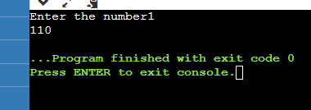

5.) WAP for adding all numbers from 1 to 20.

# include<iostream>

using namespace std;

int main()

{ int number ,sum=0;

cout<<"Enter the number";

cin>>number;

for(int i = number;i<=20;i++)

{sum+=I;}

cout<<"Total sum is:"<<sum;

return 0;}

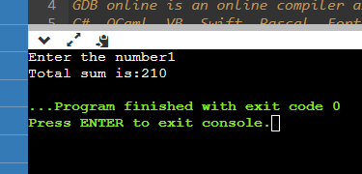

4.)WAP for printing all odd numbers from 1 to 20.

# include<iostream>

using namespace std;

int main()

{

int number;

cout<<"Enter the number";

cin>>number;

for(int i = number;i<=20;i++)

{ if(i%2 ==1){

cout<<i<<endl;} }

return 0;}

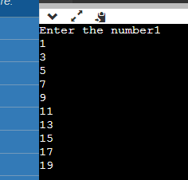

3.)WAP for printing all even numbers from 1 to 20.

# include<iostream>

using namespace std;

int main()

{

int number;

cout<<"Enter the number";

cin>>number;

for(int i = number;i<=20;i++)

{ if(i%2 !=1){

cout<<i<<endl;} }

return 0;

}

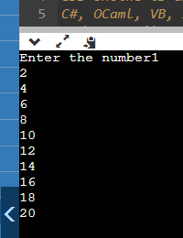

2.)WAP for printing all natural numbers in reverse order starting from 20

# include<iostream>

using namespace std;

int main()

{ int number;

cout<<"Enter the number";

cin>>number;

for(int i=number;i>=1;i--){

cout<<i<<endl; }

return 0;}

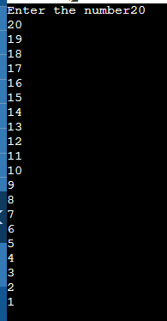

1.)WAP for printing all natural numbers till 20.

# include<iostream>

using namespace std;

int main()

{

for(int i=1;i<=20;i++)

cout<<i<<endl;

return 0;

}

